**A Crm Application For Wholesale Rice Mill**

A Project Report Submitted to

**SKILLWALLET (SmartBridge)**

in partial fulfillment of the requirements for the

Salesforce Developer Virtual Internship

**By**

**B.V.S.S.Ganesh SWUID20240012355**



**ABSTRACT**

The Rice Mill  CRM Application is a comprehensive solution designed to streamline and simplify  how much rice per day,how many were sold that rice and which type of rice all reports send to  owners daily wise. It leverages the power of customer  relationship management (CRM) to enhance customer experiences, optimize store operations, and improve overall efficiency in the rice mill factory. This project aims to develop a user-friendly and feature-rich application that addresses the specific needs of a rice mill factory.

Features and Functionality:

Reporting and Dashboards: The application can generate detailed reports and analytics regarding daily how much rice sold and total income per daily, revenue generated, popular amenities, and most buyed customers. Easy to understand the data to the owner, improving resource allocation, and planning future development.

A rollup summary field: This is a field that summarizes data from a child object to a parent object that shares a master-detail relationship. Rollup summary fields can use the COUNT, SUM, MIN, and MAX functions. For example, you could use a rollup summary field to display the total value (amount of rice supplied ) from rice  details on a related supplier.

A cross-object formula field: It  is a formula field that references fields from another object in Salesforce. This type of formula allows users to calculate the total amount from number of rice taken*price/kg  and it displays the total amount I have to pay.

 Validation rules: validation rules  also include an error message to display to the user when the rule returns a value of “True” due to an invalid value.so , In this project i gave Isblank formula.Isblank formula is used to verify whether it is blank it shows error.

 Permission sets: Organization Wide Defaults(OWD) in salesforce is the baseline level of access that the most restricted user should have. Organizational Wide Defaults are used to restrict access.But in our case we created roles and given the roles in such a way that the owner  can see   employer  and worker  records , and the employer can see the worker  records.

**TABLE OF CONTENTS**

**Title Page No.**

**ABSTRACT** .................................................................................................................. i

**TABLE OF CONTENTS** ............................................................................................. ii

**LIST OF FIGURES** ...................................................................................................... iv

**CHAPTER 1 INTRODUCTION**

1.1 Introduction to the Topic…........................................................................................2

1.2 Problem Statement.………………………... .............................................................2

**CHAPTER 2 METHODOLOGY**

2.1 Objects…………....................................................................................................... 4

2.2 Tabs …………………………..………………........................................................ 6

2.3 The lightening app…...................................................................................................7

2.4 Fields………………………......................................................................................8

2.5 Page layouts…. ...............................................................................................11

2.6 Profiles……………………………............................................................................11

2.7 Roles an d role hierarchy ……….…………………………………………………..13

2.8 Users………………………………………………………………………………..14

2.9 Permission sets……………………………………………………………………..14

2.10 Reports……………………………………………………………………………..15

2.11 Dashboards…..………………………………………………………………………..16

**CHAPTER 3 CONCLUSION AND FUTURE WORK 17**

**List of Figures**

**Name of the figure Pg.no**

Figure 2.1.1 Consumer object 4  Figure 2.1.2 Rice mill object 5

Figure 2.1.3 Rice detail object 5

Figure 2.1.4 Supplier object 6

Figure 2.2.1 Tabs 7

Figure 2.3.2 The lightening app 8

Figure 2.4.1 Consumer fields 9

Figure 2.4.2 Rice details fields 9

Figure 2.4.3 Rice mill fields 10

Figure.2.4.4 Supplier fields 10

Figure.2.4.5 Validation fields 11

Figure 2.5.1 Consumer page layout 11

Figure 2.6.1 Employer profile 12

Figure 2.6.2 Owner profile 13

Figure 2.6.3 Worker profile 13

Figure 2.7.1 Roles and role hierarchy 14

Figure 2.8.1 Users 14

Figure 2.9.1 OWD 15

Figure 2.10.1 Reports 16

Figure 2.11.1 Dashboards 16

# INTRODUCTION

The Rice Mill CRM Application is a comprehensive solution designed to streamline and simplify daily operations in a rice mill factory. It leverages the power of customer relationship management (CRM) to enhance customer experiences, optimize store operations, and improve overall efficiency. This project aims to develop a user-friendly and feature-rich application that addresses the specific needs of a rice mill factory. Features and Functionality:

Reporting and Dashboards: The application generates detailed reports and analytics regarding daily rice sales, total income, revenue generated, popular products, and top customers. These easy-to-understand reports help owners improve resource allocation and plan for future development.

Rollup Summary Field: This field summarizes data from a child object to a parent object in a master-detail relationship. It can use COUNT, SUM, MIN, and MAX functions. For example, it can display the total value (amount of rice supplied) from rice details on a related supplier.

Cross-Object Formula Field: This formula field references fields from another object in Salesforce. It calculates the total amount owed by multiplying the number of rice units taken by the price per kilogram, displaying the total amount payable.

Validation Rules: Validation rules include error messages that display when the rule returns a value of “True” due to an invalid entry. For this project, the IsBlank formula is used to check for blank values and show an error if a required field is empty.

Permission Sets: Organization-Wide Defaults (OWD) in Salesforce set the baseline level of access for the most restricted user. In this project, roles are created such that the owner can see employer and worker records, while the employer can see worker records.

This ensures appropriate access and security. Overall, the Rice Mill CRM Application is designed to provide valuable insights and streamline processes, making it an essential tool for any rice mill factory.

* 1. **Problem Statement**

In the highly competitive rice milling industry, efficient management and streamlined operations are crucial for maintaining profitability and customer satisfaction. Rice mill factories face numerous challenges, including tracking daily rice production, managing sales, monitoring inventory, and ensuring accurate financial reporting. Traditional manual methods and disparate systems often lead to inefficiencies, data inaccuracies, and a lack of real-time insights, hindering effective decision-making and resource allocation. Rice mill owners need a comprehensive solution that can integrate various aspects of their operations, providing a unified platform for tracking production, sales, and revenue.

They require detailed, daily reports that offer insights into how much rice is produced and sold, which types of rice are most popular, and who the top customers are. Additionally, the solution must ensure data accuracy, secure access control, and ease of use for different user roles within the organization.

Therefore, there is a need for a robust Customer Relationship Management (CRM) application specifically tailored to the unique requirements of rice mill factories. This application should provide advanced reporting capabilities, automated data summarization, cross-object calculations, and validation rules to enhance operational efficiency and accuracy. It should also include flexible permission settings to ensure that data is accessible only to authorized personnel, based on their roles and responsibilities. The Rice Mill CRM Application aims to address these challenges by delivering a feature-rich, user-friendly solution that optimizes daily operations, enhances customer experiences, and supports informed decision-making in rice mill factories.

# 2.Modules

**2.1 Object**

Salesforce objects are database tables that permit you to store data that is specific to an organization. What are the types of Salesforce objects

Salesforce objects are of two types:

1. Standard Objects: Standard objects are the kind of objects that are provided by salesforce.com such as users, contracts, reports, dashboards, etc.
2. Custom Objects: Custom objects are those objects that are created by users. They supply information that is unique and essential to their organization. They are the heart of any application and provide a structure for sharing data.

To Navigate to Setup page:

Click on gear icon -click setup.

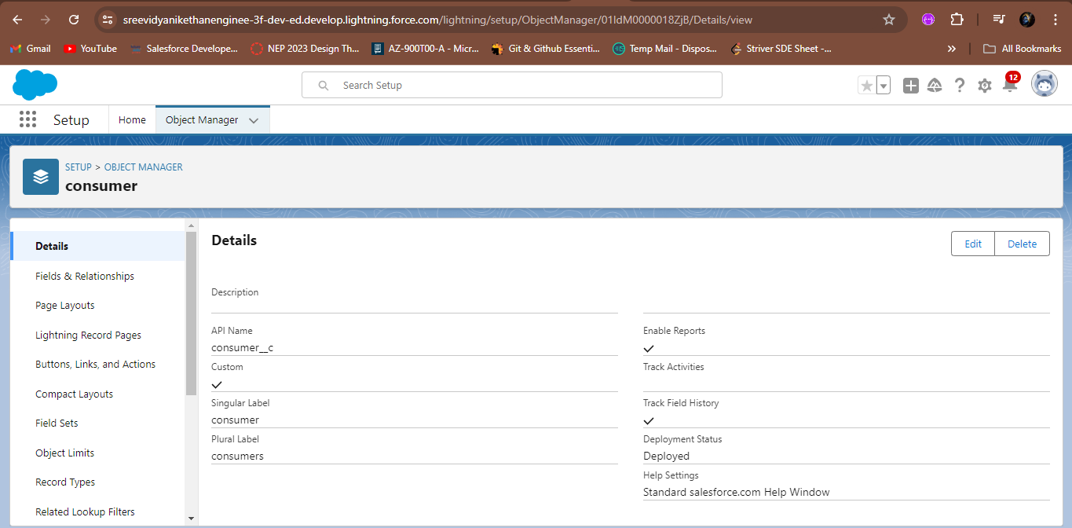

* + 1. Consumer object

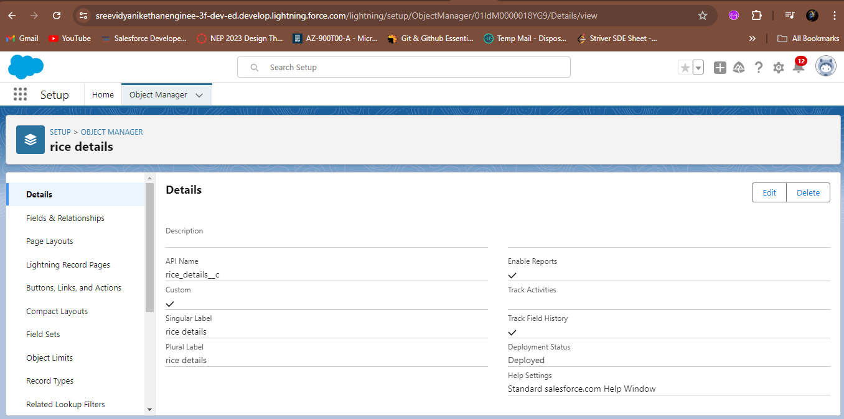

2.1.2 Rice details object

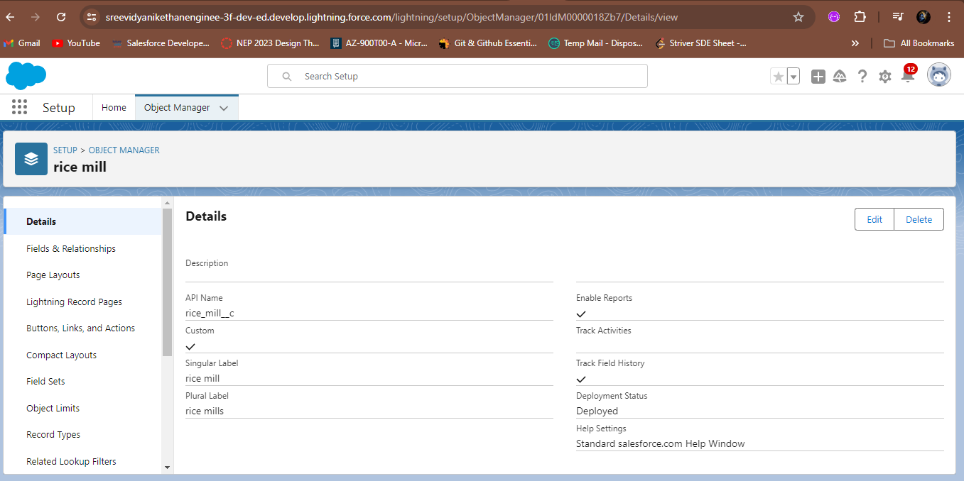

2.1.3 Rice mill object

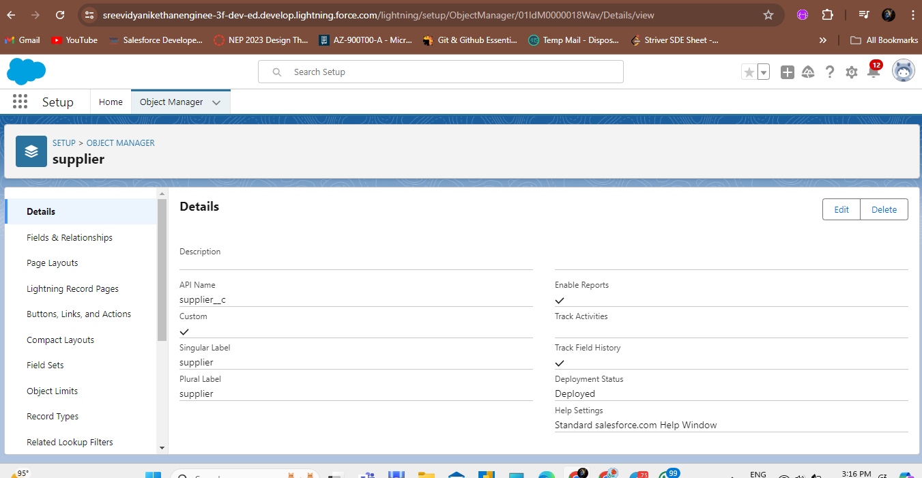

2.1.4 Supplier object

**2.2 Tabs**

 A tab is like a user interface that is used to build records for objects and to view the records in the objects.

Types of Tabs:

        Custom Tabs

Custom object tabs are the user interface for custom applications that you build in salesforce.com. They look and behave like standard salesforce.com tabs such as accounts, contacts, and opportunities.

Web Tabs

Web Tabs are custom tabs that display web content or applications embedded in the salesforce.com window. Web tabs make it easier for your users to quickly access content and applications they frequently use without leaving the salesforce.com application.

Visualforce Tabs

Visualforce Tabs are custom tabs that display a Visualforce page. Visualforce tabs look and behave like standard salesforce.com tabs such as accounts, contacts, and opportunities.

Lightning Component Tabs

Lightning Component tabs allow you to add Lightning components to the navigation menu in Lightning Experience and the mobile app.

Lightning Page Tabs

Lightning Page Tabs let you add Lightning Pages to the mobile app navigation menu.

Lightning Page tabs don't work like other custom tabs. Once created, they don't show up on the All Tabs page when you click the Plus icon that appears to the right of your current tabs. Lightning Page tabs also don't show up in the Available Tabs list when you customize the tabs for your apps.

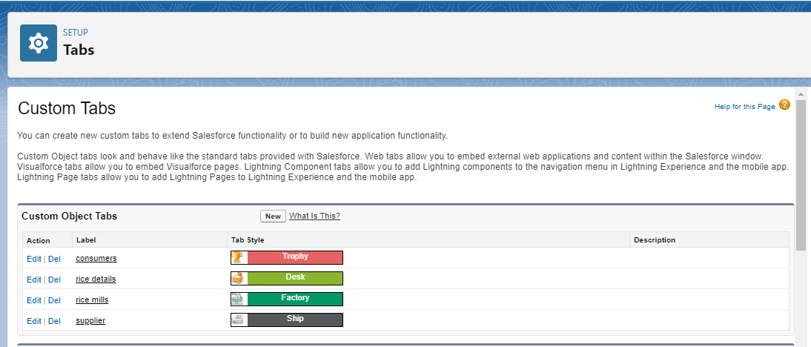

3.2.1 Tabs

**2.3 The Lightning App**

An app is a collection of items that work together to serve a particular function. In Lightning Experience, Lightning apps give your users access to sets of objects, tabs, and other items all in one convenient bundle in the navigation bar.

Lightning apps let you brand your apps with a custom color and logo. You can even include a utility bar and Lightning page tabs in your Lightning app. Members of your org can work more efficiently by easily switching between apps.

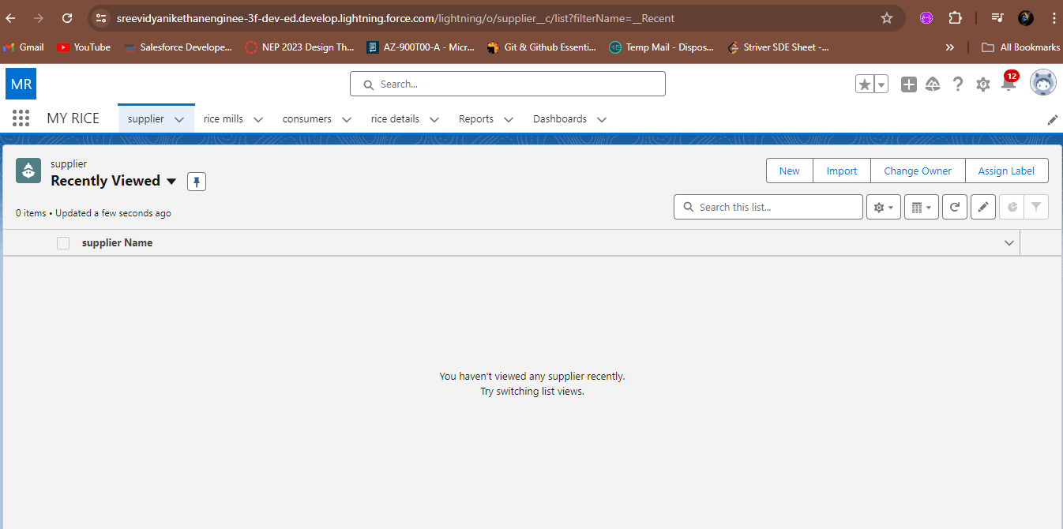

2.3.1 The lightning app

**2.4 Fields**

When we talk about Salesforce, Fields represent the data stored in the columns of a relational database. It can also hold any valuable information that you require for a specific object. Hence, the overall searching, deletion, and editing of the records become simpler and quicker.

Types of Fields

1. Standard Fields
2. Custom Fields

Standard Fields:

As the name suggests, the Standard Fields are the predefined fields in Salesforce that perform a standard task. The main point is that you can’t simply delete a Standard Field until it is a non-required standard field. Otherwise, users have the option to delete them at any point from the application freely. Moreover, we have some fields that you will find common in every Salesforce application. They are,

1. Created By

2. Owner

3. Last Modified

4. Field Made During object Creation

Custom Fields:

On the other side of the coin, Custom Fields are highly flexible, and users can change them according to requirements. Moreover, each organizer or company can use them if necessary. It means you need not always include them in the records, unlike Standard fields. Hence, the final decision depends on the user, and he can add/remove Custom Fields of any given form.

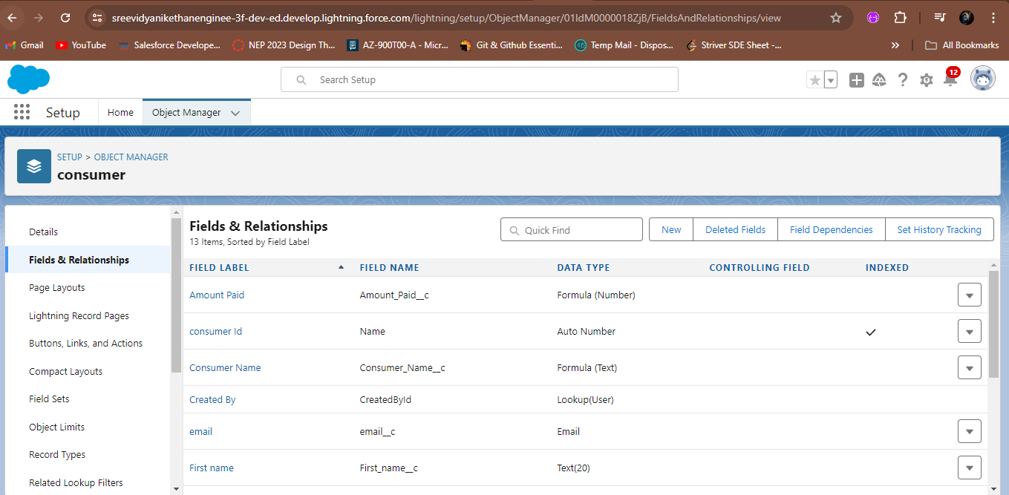

2.4.1Consumerfields

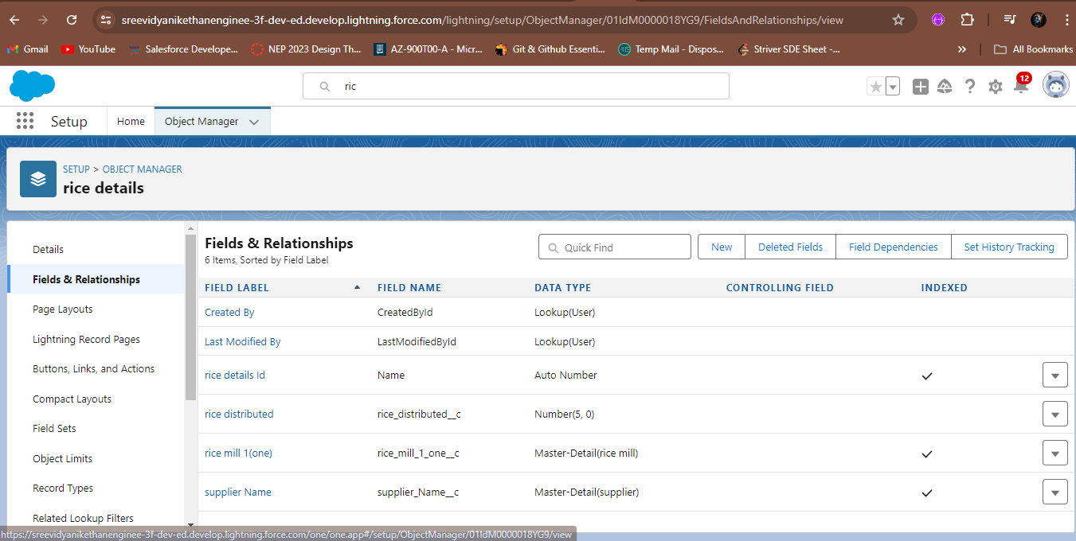

2.4.2 Rice details fields

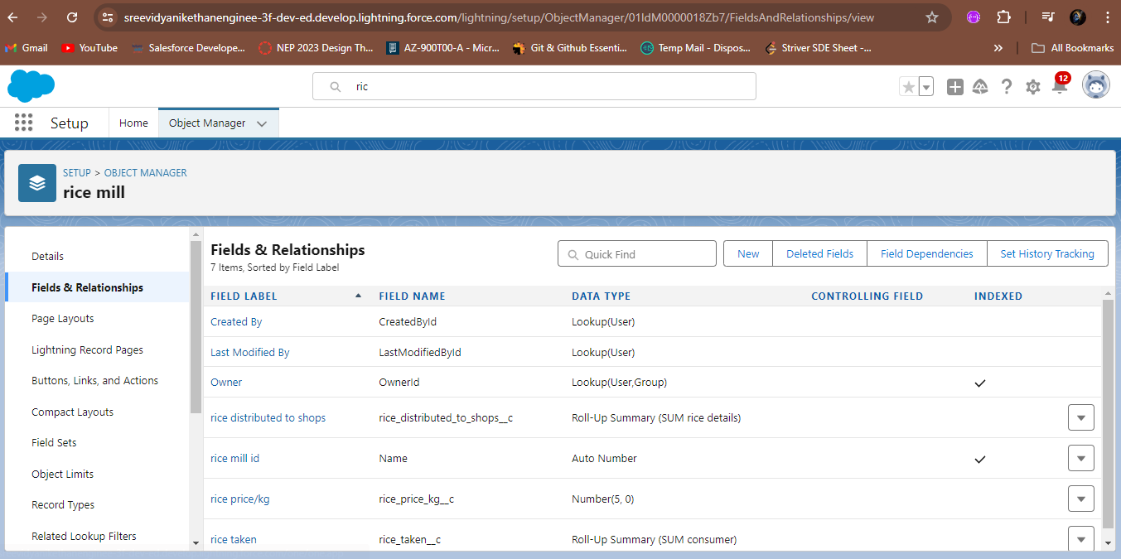

2.4.3 Rice mill fields

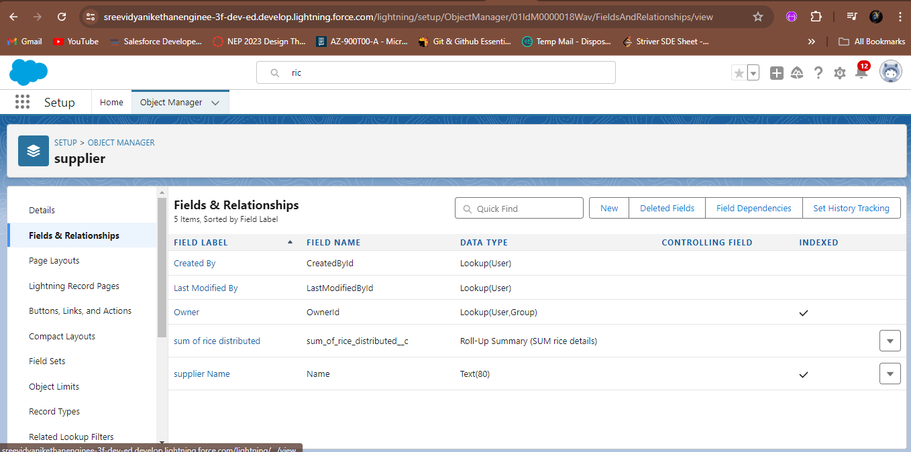

2.4.4 Supplier fields

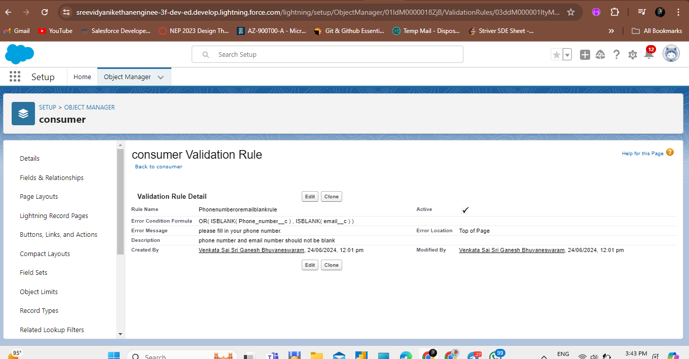

2.4.5 Consumer validation rule

**2.5 Page Layouts**

Page Layout in Salesforce allows us to customize the design and organize detail and edit pages of records in Salesforce. Page layouts can be used to control the appearance of fields, related lists, and custom links on standard and custom objects' detail and edit pages.

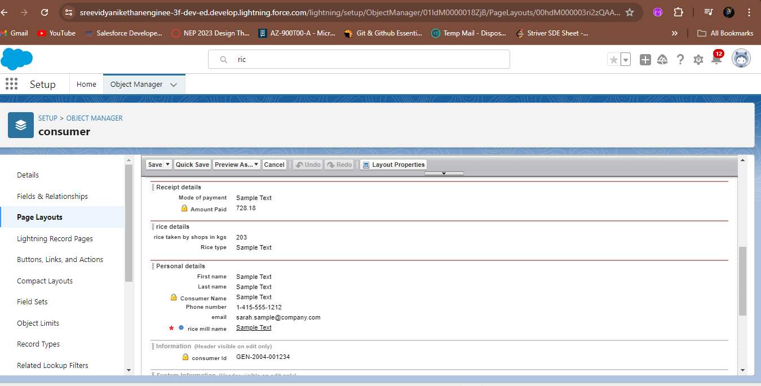

2.5.1 Consumer page layout

**2.6 Profiles**

A profile is a group/collection of settings and permissions that define what a user can do in salesforce. Profile controls “Object permissions, Field permissions, User permissions, Tab settings, App settings, Apex class access, Visualforce page access, Page layouts, Record Types, Login hours & Login IP ranges. You can define profiles by the user's job function. For example System Administrator, Developer, Sales Representative.

Types of profiles in salesforce

1. Standard profiles:

By default salesforce provides below standard profiles.

* Contract Manager
* Read Only
* Marketing User
* Solutions Manager
* Standard User
* System Administrator.

We cannot deleted standard ones

Each of these standard ones includes a default set of permissions for all of the standard objects available on the platform.

1. Custom Profiles:

Custom ones defined by us.

They can be deleted if there are no users assigned with that particular one.

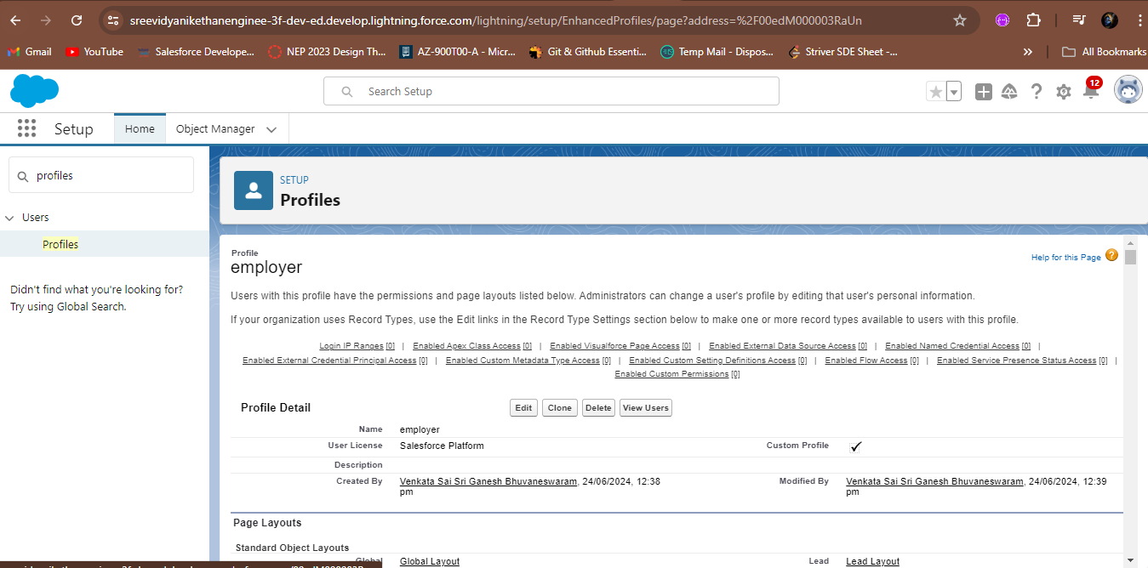

2.6.1 Employer profile

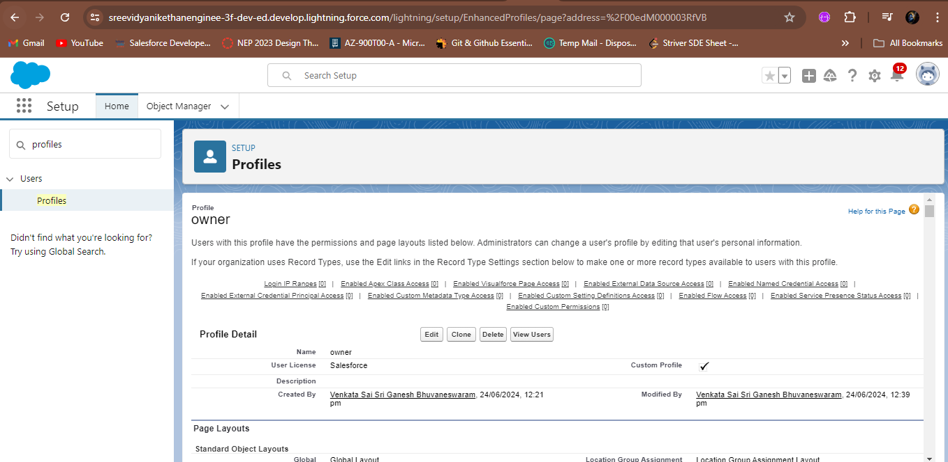

2.6.2 Owner profile

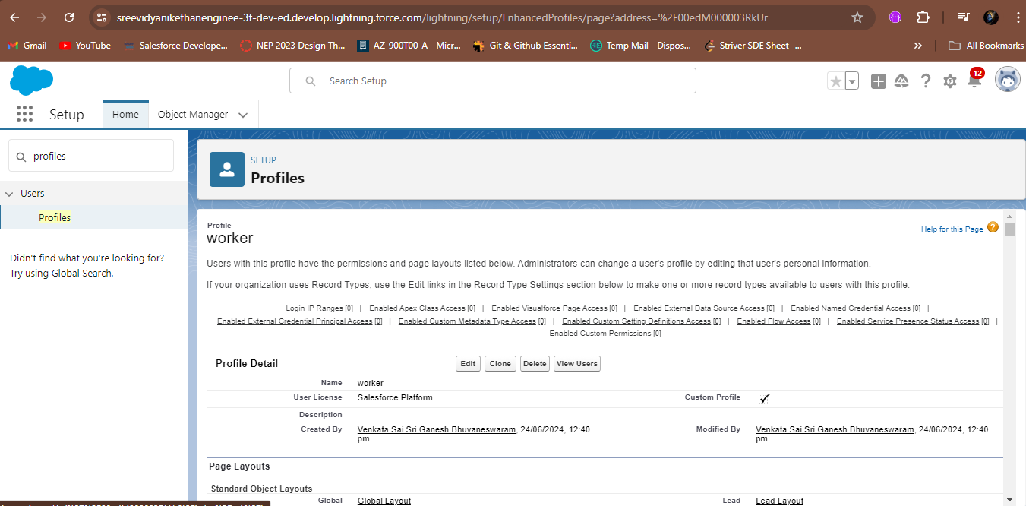

2.6.3 Worker profile

**2.7 Roles and Role Hierarchy**

A role in Salesforce defines a user's visibility access at the record level. Roles may be used to specify the types of access that people in your Salesforce organization can have to data. Simply put, it describes what a user could see within the Salesforce organization.

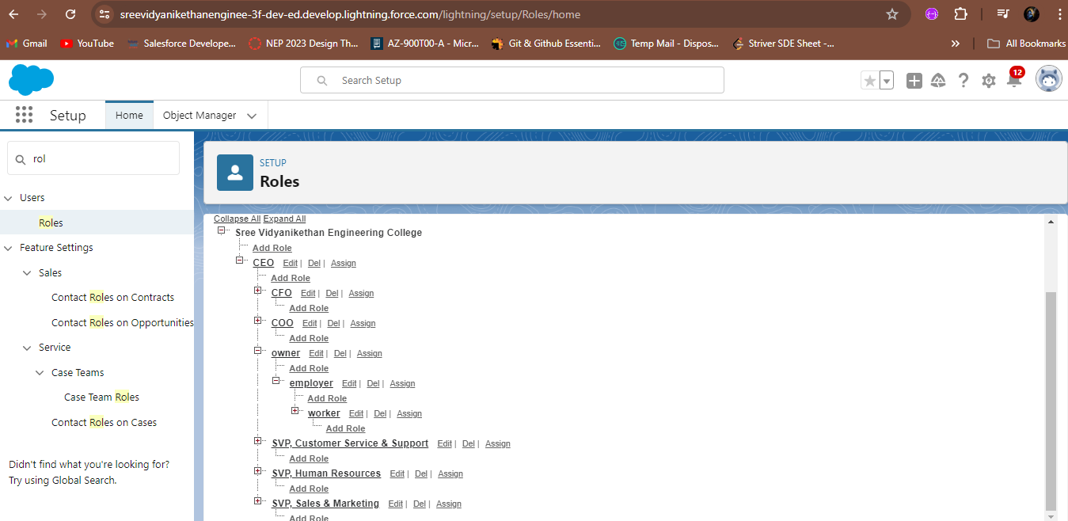

2.7.1 Roles and role hierarchy

**2.8 Users**

A user is anyone who logs in to Salesforce. Users are employees at your company, such as sales reps, managers, and IT specialists, who need access to the company's records. Every user in Salesforce has a user account. The user account identifies the user, and the user account settings determine what features and records the user can access.

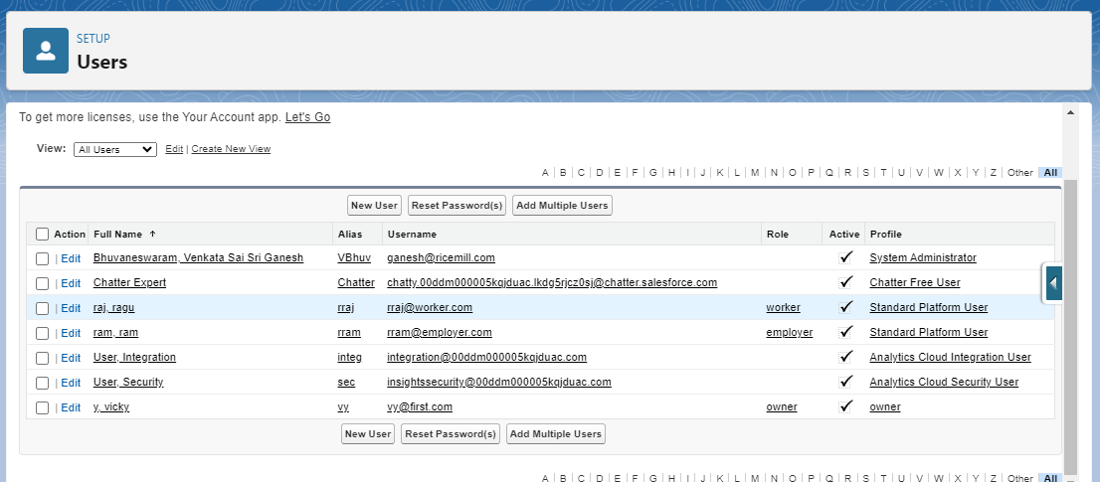

2.8.1 User

**2.9 Permission Sets**

A permission set is a collection of settings and permissions that give users access to various tools and functions. Permission sets extend users’ functional access without changing their profiles and are the recommended way to manage your users’ permissions.



2.9.1 sharing settings

**2.10 Reports**

Reports give you access to your Salesforce data. You can examine your Salesforce data in almost infinite combinations, display it in easy-to-understand formats, and share the resulting insights with others. Before building, reading, and sharing reports, review these reporting basics.

In Salesforce.com we can easily generate reports in different styles. And can create reports in a very short time and also schedule the reports. Salesforce provides a powerful suit of analytic tools to help you organize, view and analyze your data.

Types of Reports in Salesforce

1. Tabular
2. Summary
3. Matrix
4. Joined Reports

1. Tabula Reports: Simple listing of data without any subtotals. This type of reports provide you most basically to look at your data. Use tabular reports when you want a simple list or a list of items with a grand total.

Example: This type of reports are used to list all accounts, List of contacts, List of opportunities…..etc.….

2. Summary Reports: This type of reports provide a listing of data with groupings and sub totals. Use summary reports when you want subtotals based on the value of a particular field or when you want to create a hierarchically grouped report, such as sales organized by year and then by quarter.

Example: All opportunities for your team sub totaled by Sales Stage and Owner.

3. Matrix Reports: This type of reports allow you to group records both by row and by column. A comparison of related totals, with totals by both row and column. Use matrix reports when you want to see data by two different dimensions that aren’t related, such as date and product.

Example: Summarize opportunities by month vertically and by account horizontally.

4. Joined Reports: Blocks of related information in a single report. This type of reports enable you to adopt five different blocks to display different types of related data. Each block can own unique columns, summary fields, formulas, filters and sort order. Use joined reports to group and show data from multiple report types in different views.

Example: You can build a report to show opportunity, case and activity data for your accounts.

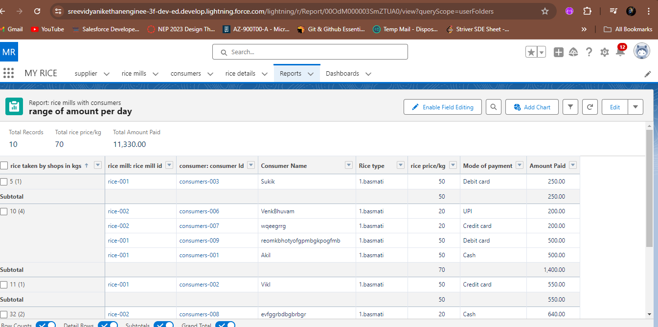

2.10.1 Reports

**2.11 Dashboards**

Dashboards help you visually understand changing business conditions so you can make decisions based on the real-time data you’ve gathered with reports. Use dashboards to help users identify trends, sort out quantities, and measure the impact of their activities. Before building, reading, and sharing dashboards, review these dashboard basics.

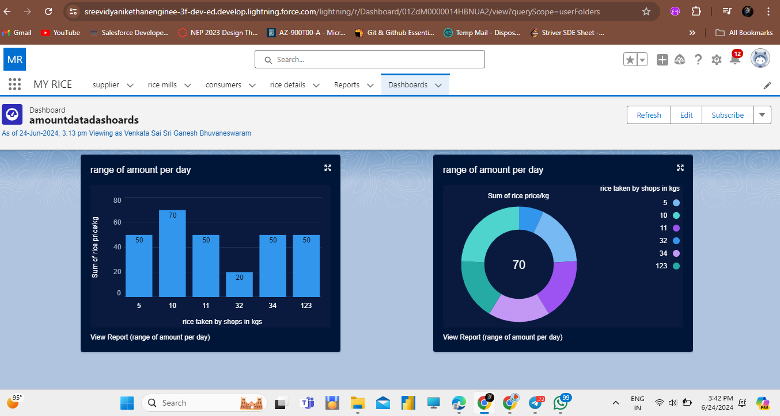

* + 1. Dashboards

# 3. CONCLUSION AND FUTURE WORK

The Rice Mill CRM Application is poised to revolutionize the operational efficiency and customer relationship management within rice mill factories. By integrating advanced reporting capabilities, automated data summarization, cross-object calculations, and stringent validation rules, this application addresses the unique challenges faced by rice mill owners. It ensures accurate, real-time insights into daily production, sales, and revenue, facilitating informed decision-making and strategic planning.

Moreover, the application’s user-friendly interface and tailored permission settings provide secure and role-based access to critical data, enhancing transparency and accountability within the organization. As a comprehensive solution, the Rice Mill CRM Application not only streamlines operations but also significantly improves resource allocation, customer satisfaction, and overall business performance.

In summary, the Rice Mill CRM Application is an essential tool for rice mill factories, designed to meet their specific needs and drive sustainable growth and success in a competitive industry.